DATA ANALYST – PORTFOLIO

Part 1 **MYSQL server**

* Import data
* Create database
* Create queries
* Creating report

Part 2 **Power BI**

* Connecting Ms sql server (data source here is ms sql server)
* Data cleaning process (Power querry tool)
* Data processing
* Data visualization

Creating dashboards (we will create 2 dashboards – 1st best selling 2nd worst selling)

A **Key Performance Indicator (KPI)** is a visual cue that communicates the amount of progress made toward a measurable goal

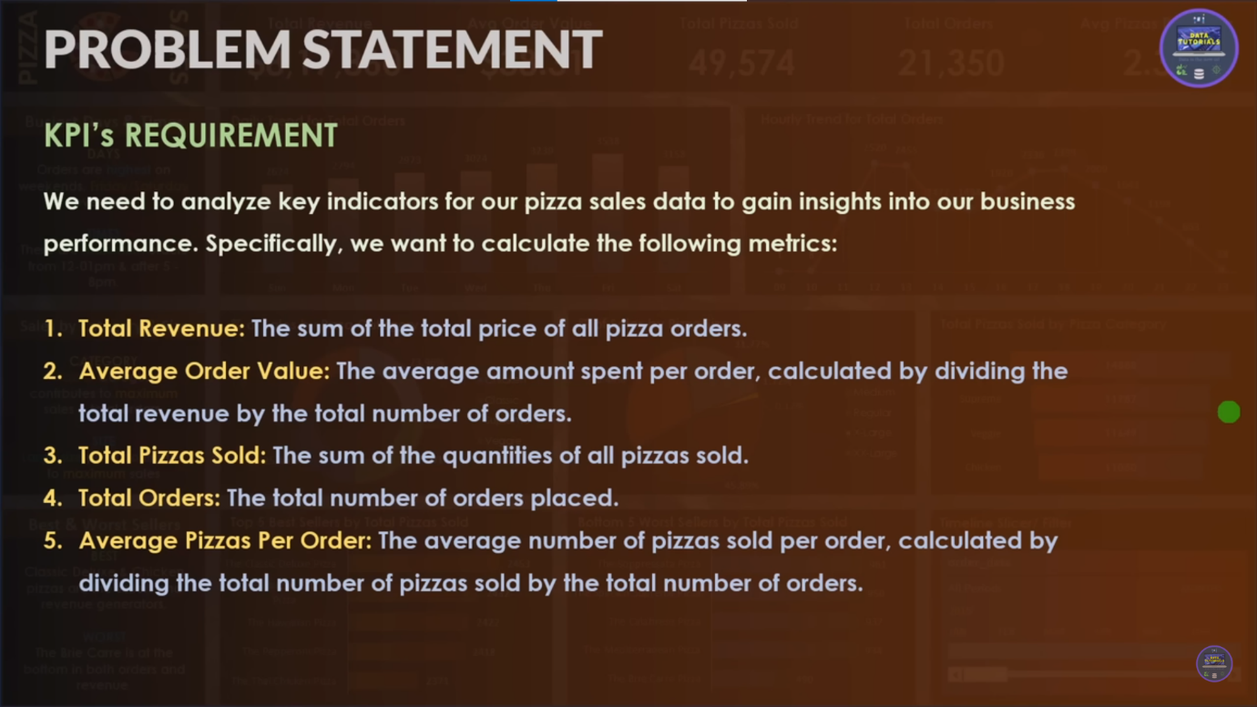

When to use a KPI

KPIs are a great choice:

* To measure progress. Answers the question, "What am I ahead or behind on?"
* To measure distance to a goal. Answers the question, "How far ahead or behind am I?"

KPI requirements

A designer bases a KPI visual on a specific measure. The intention of the KPI is to help you evaluate the current value and status of a metric against a defined target. A KPI visual requires a *base* measure that evaluates to a value, a *target* measure or value, and a *threshold* or *goal*.

**CHARTS REQUIREMENT -**

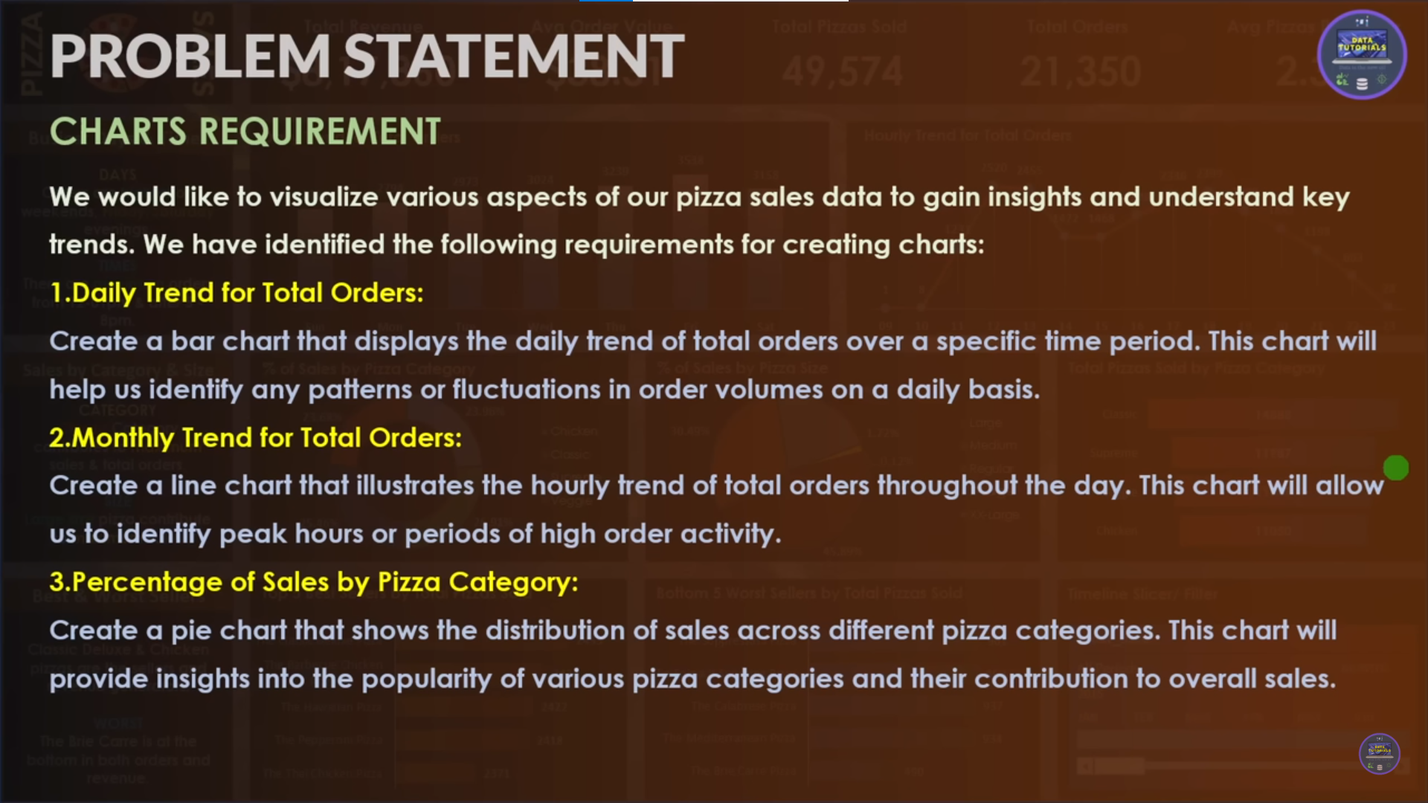

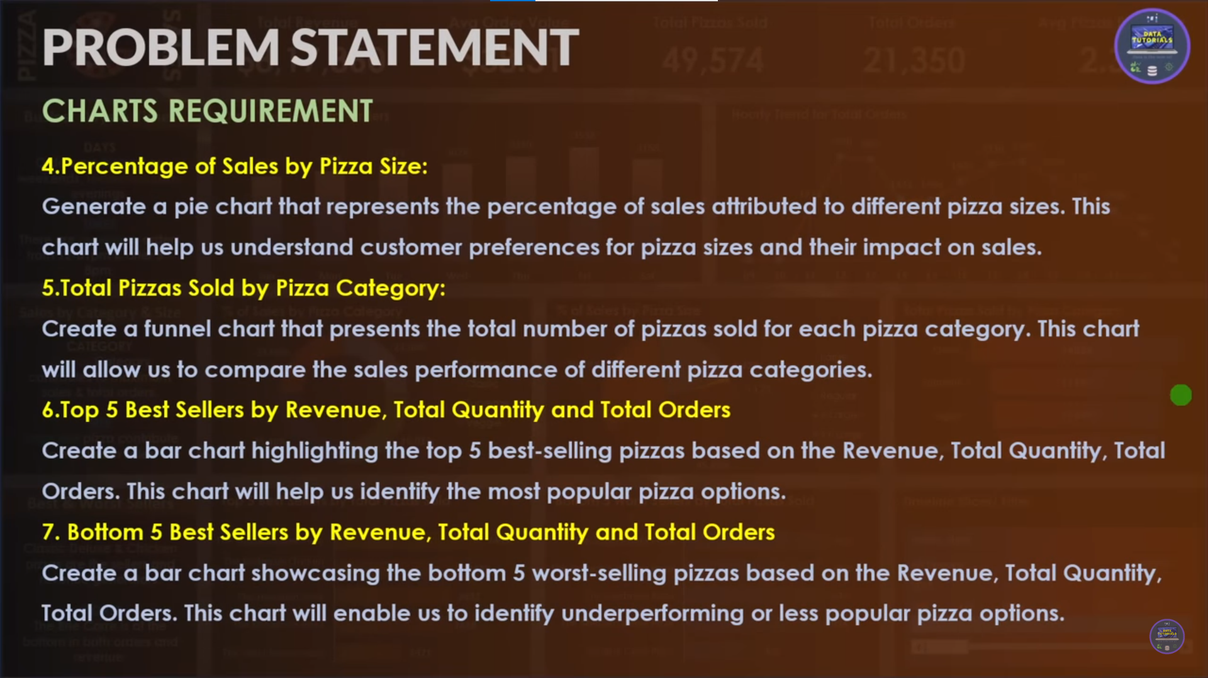

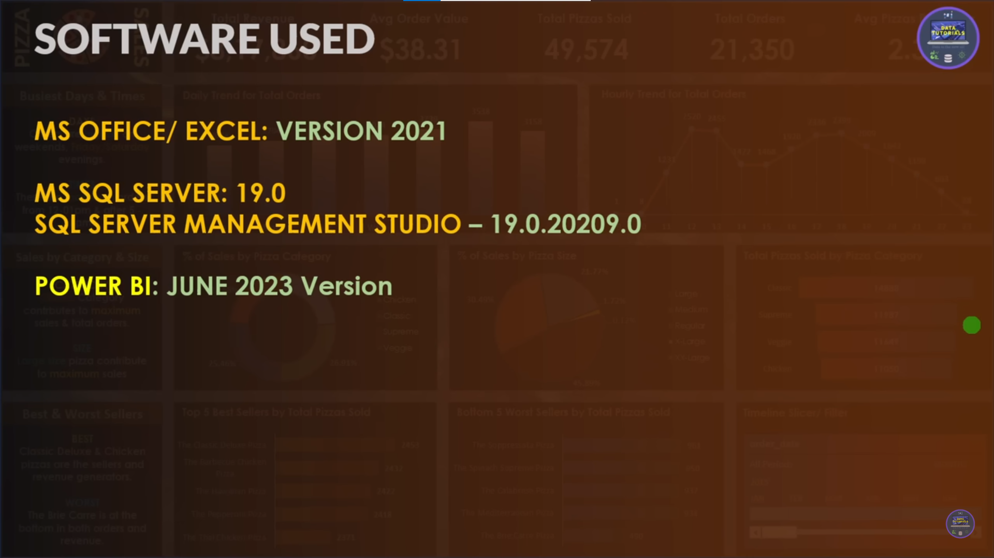

KPI (key performance indicator)USED

QUERRIES USED ARE-

1 . for TOTAL REVENUE – the total Sum Is total revenue

select SUM(total_price) AS Total_Revenue from pizza_sales

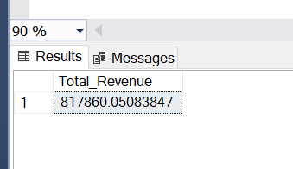

2. AVERAGE ORDER VALUE –

SELECT SUM(total_price) / COUNT(DISTINCT order_id) AS Avg_order_Value from pizza_sales

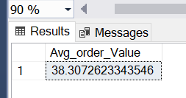

3. TOTAL PIZZA SOLD – sum of all quantities

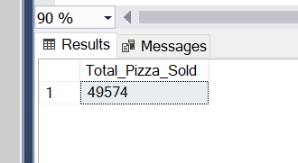

4. Total ORDER – total orders

SELECT COUNT(DISTINCT order_id) AS Total_orders from pizza_sales

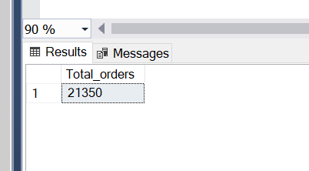

5. AVERAGE PIZZAS PER ORDER -

SELECT CAST(SUM(quantity) AS DECIMAL (10,2)) /

CAST(COUNT (DISTINCT order_id) AS DECIMAL(10,2)) AS Average_pizza_per_order from pizza_sales

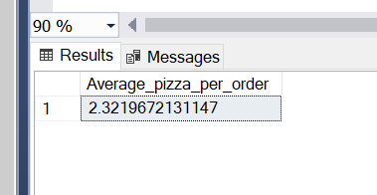

(here cast function is used as CAST (X AS DECIMAL(10,2) means upto 10 decimals places but only 2 will be shown as output Here if we cast whole then final output will be in 2 decimals)

**CHART REQUIREMENTS**

1. DAILY TRENDS FOR TOTAL ORDER – all orders placed on all week days

SELECT DATENAME(DW, order_date) AS order_day, COUNT(DISTINCT order_id) AS Total_orders

from pizza_sales

GROUP BY DATENAME(DW, order_date)

NOTE – whenever u are bringing column and using with aggregate You have to use GROUP BY clause always so it will be grouping

GROUP BY ‘CATEGORICAL FIELD’

DATE Name function is used here

Above querry DW is used to retrieve name of week

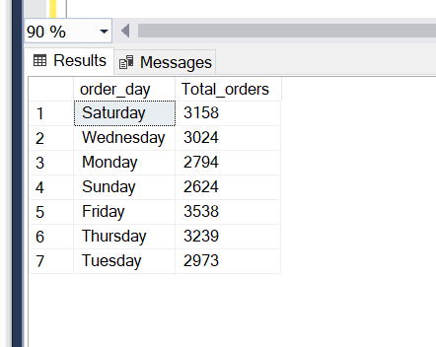

2. MONTLY TREND OF TOTAL ORDERS - DATENAME function will be used , parameter1 will be MONTH, for which month so parameter2 order_date

SELECT DATENAME(MONTH, order_date) AS Month_Name, COUNT(DISTINCT order_id) AS Total_Orders

FROM pizza_sales

GROUP BY DATENAME(MONTH, order_date)

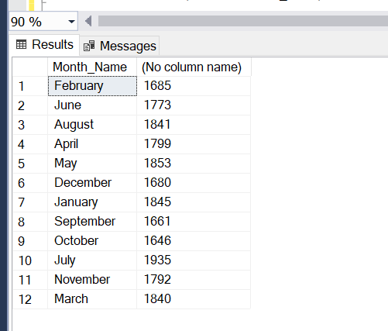

To know which month has high we can order Total_Orders as decending order

SELECT DATENAME(MONTH, order_date) AS Month_Name, COUNT(DISTINCT order_id) AS Total_Orders

FROM pizza_sales

GROUP BY DATENAME(MONTH, order_date)

ORDer BY Total_Orders DESC

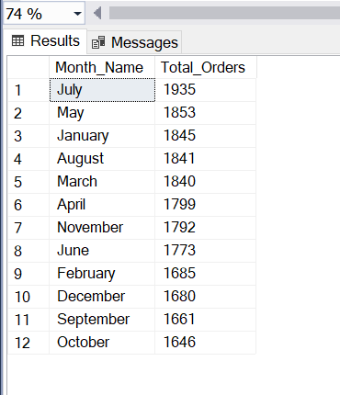

3. Percentage of Sales by Pizza Category –

SELECT pizza_category, SUM(total_price) as Total_Sales, SUM(total_price) * 100 / (SELECT SUM(total_price) from pizza_sales WHERE MONTH(order_date)=1 ) AS PCT

FROM pizza_sales

WHERE MONTH(order_date) = 1

GROUP BY pizza_category

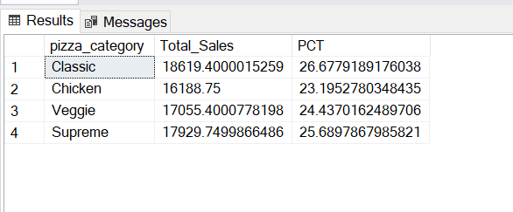

4. TOP 5 BEST SELLER BY REVENUE-

SELECT pizza_name, SUM(total_price) AS Total_Revenue FROM pizza_sales

GROUP BY pizza_name

ORder BY Total_Revenue DESC

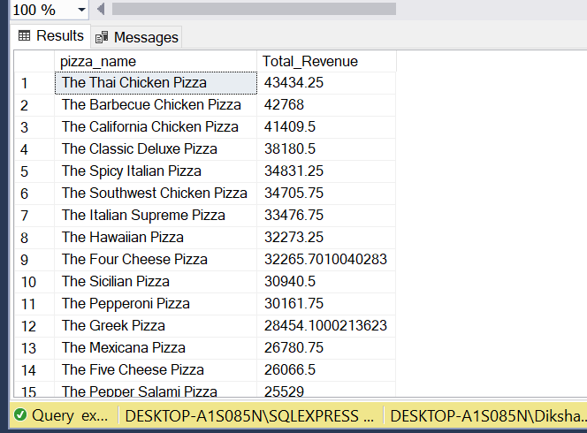

**FOR TOP 5 we will use TOP command**

SELECT TOP 5 pizza_name, SUM(total_price) AS Total_Revenue FROM pizza_sales

GROUP BY pizza_name

ORder BY Total_Revenue DESC

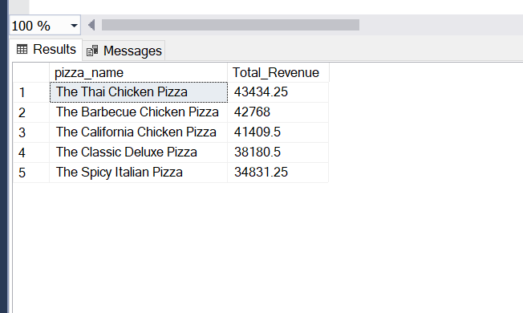

**FOR Bottom 5 we will use TOP command – just remove desc or add ASC in last line**

SELECT TOP 5 pizza_name, SUM(total_price) AS Total_Revenue FROM pizza_sales

GROUP BY pizza_name

ORder BY Total_Revenue ASC

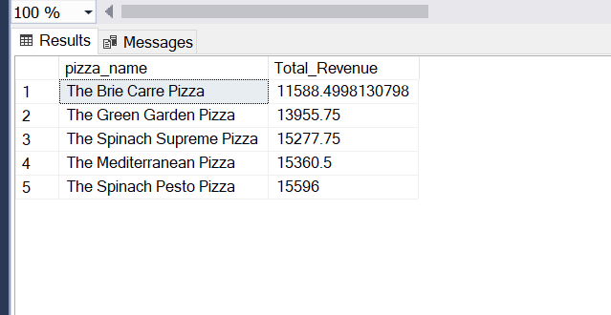

TOP 5 BEST SELLER BY Quantity

SELECT TOP 5 pizza_name, SUM(quantity) AS Total_Quantity FROM pizza_sales

GROUP BY pizza_name

ORder BY Total_Quantity DESC

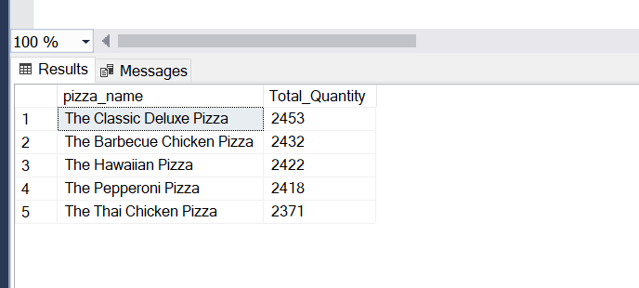

**PART 2 - POWER BI (DASHBOARD)**

1. Connect database to power bi
2. We will perform data transform first then

3)

Data Cleaning will be done

Eg = 1st replace-ment done

Like XLarge converted to X-Large

Like M to Medium

1. Apply changes
2. Go to visuals
3. First we will just make all the KPI structure
4. Go to Measure and create them all
5. TOTAL REVENUE - For this we need Total number of orders

Calculate the total number of orders i.e so find 4th KPI first

Total Revenue = SUM(pizza_sales[total_price]

1. Average Order Value - For this we need Total number of orders is number of id i.e distinct id

Calculate the total number of orders i.e so find 4th KPI first

Querry are used as -

Order Day = UPPER(LEFT(pizza_sales[Day Name],3))